Project Overview
The purpose of this project was to develop an interactive dashboard for Grazioso Salvare that connects to the Austin Animal Center database. The dashboard allows users to filter animal records based on specific rescue requirements and view the results through an interactive data table, chart, and geolocation map.
The dashboard uses the CRUD Python module developed earlier in the course to communicate directly with the MongoDB database. This allows the dashboard to retrieve animal records based on the rescue type selected by the user.

Tools and Technologies
The following tools and technologies were used to develop the dashboard:
- Python – Used for the primary application logic.
- MongoDB – Used to store and retrieve animal shelter data.
- CRUD Python Module – Provides database access between the dashboard and MongoDB.
- Dash / JupyterDash – Used to create the interactive web dashboard.
- Pandas – Used to organize and manipulate the animal data.
- Plotly Express – Used to create the interactive pie chart.
- Dash Leaflet – Used to display animal locations on an interactive map.
- Jupyter Notebook / Codio – Used as the development environment.
These tools were selected because they allow the database, user interface, data visualization, and geolocation functionality to work together within one application.

Dashboard Functionality
Default Dashboard / Reset View
The dashboard initially displays the animal shelter records in an interactive data table. The Reset option removes the rescue-specific filtering and returns the dashboard to the complete dataset. The chart displays the most common breeds in the current data, while the map displays the location associated with the selected animal.
Screenshot 1 – Default/Reset Dashboard
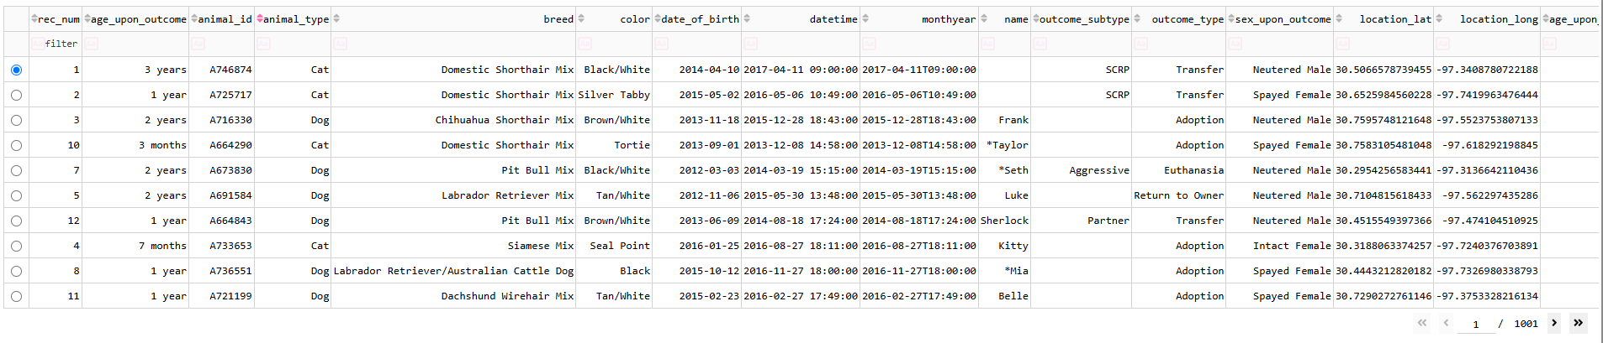
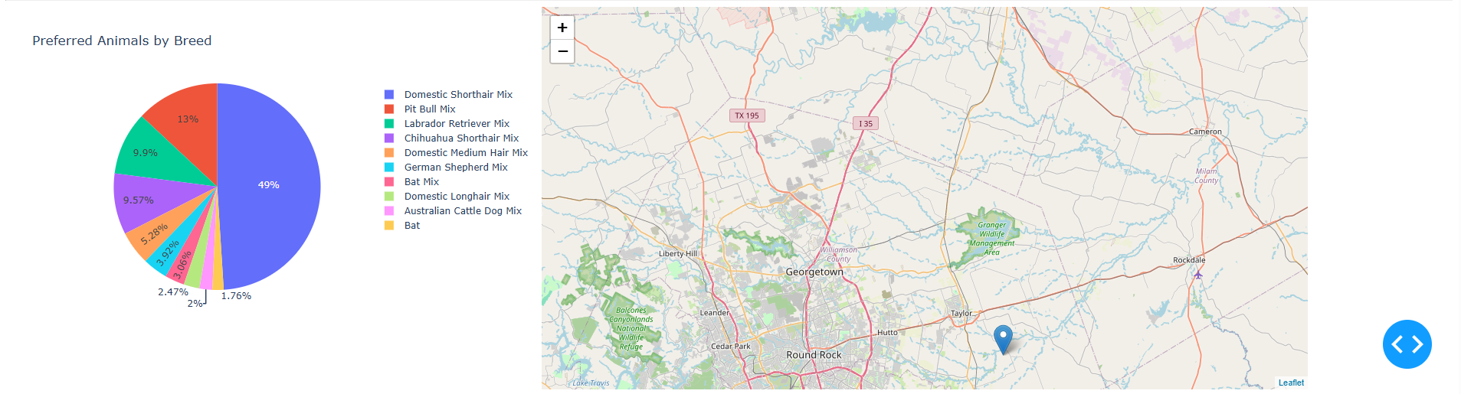
Figure 1. Grazioso Salvare dashboard displaying the default dataset with the Reset option selected.

Water Rescue Filter
Selecting Water Rescue filters the database to display dogs that meet the requirements for water rescue work. The data table automatically updates, and the pie chart displays the breeds represented within the filtered results.
Screenshot 2 – Water Rescue
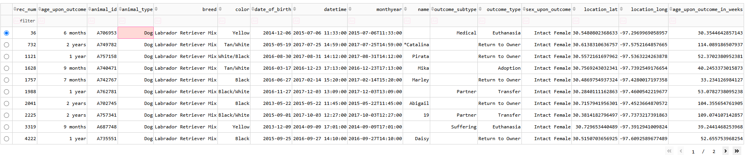
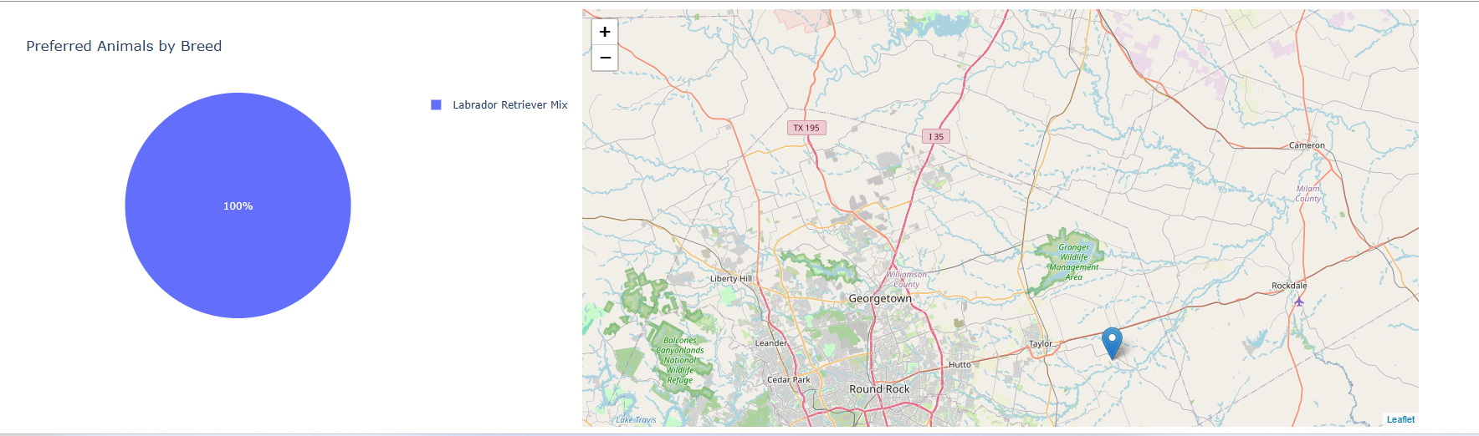
Figure 2. Dashboard results after applying the Water Rescue filter.

Mountain or Wilderness Rescue Filter
Selecting Mountain or Wilderness Rescue filters the animal records according to the requirements associated with this rescue category. The table and visualization dynamically update based on the selected filter.
Screenshot 3 – Mountain or Wilderness Rescue
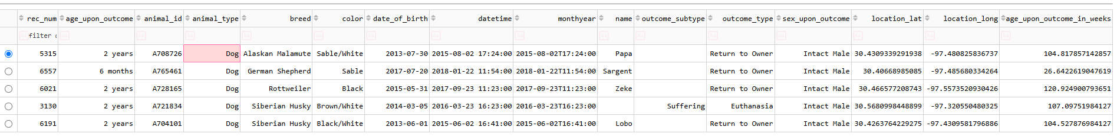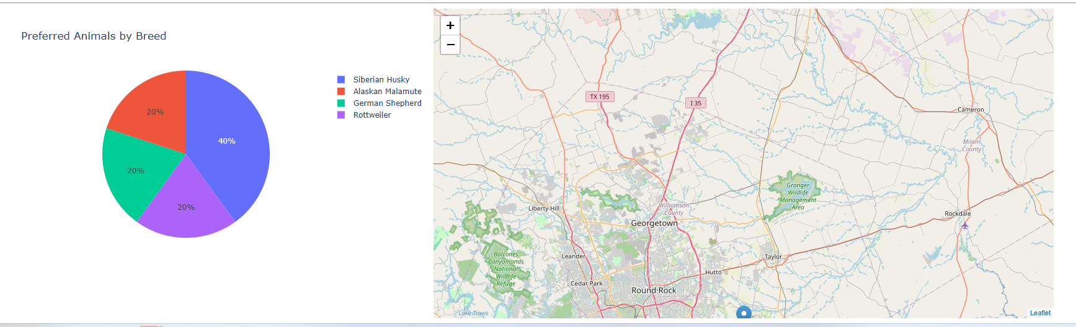Figure 3. Dashboard results after applying the Mountain or Wilderness Rescue filter.

Disaster or Individual Tracking Filter
The Disaster or Individual Tracking option filters the database for animals that meet the requirements associated with disaster response or individual tracking. As with the other filters, the data table and chart automatically respond to the user's selection.
Screenshot 4 – Disaster or Individual Tracking
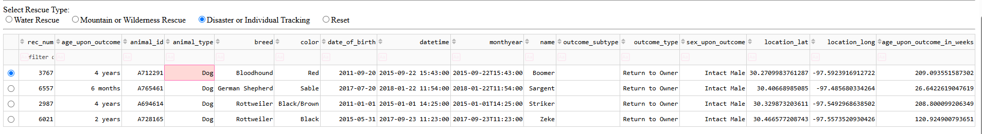
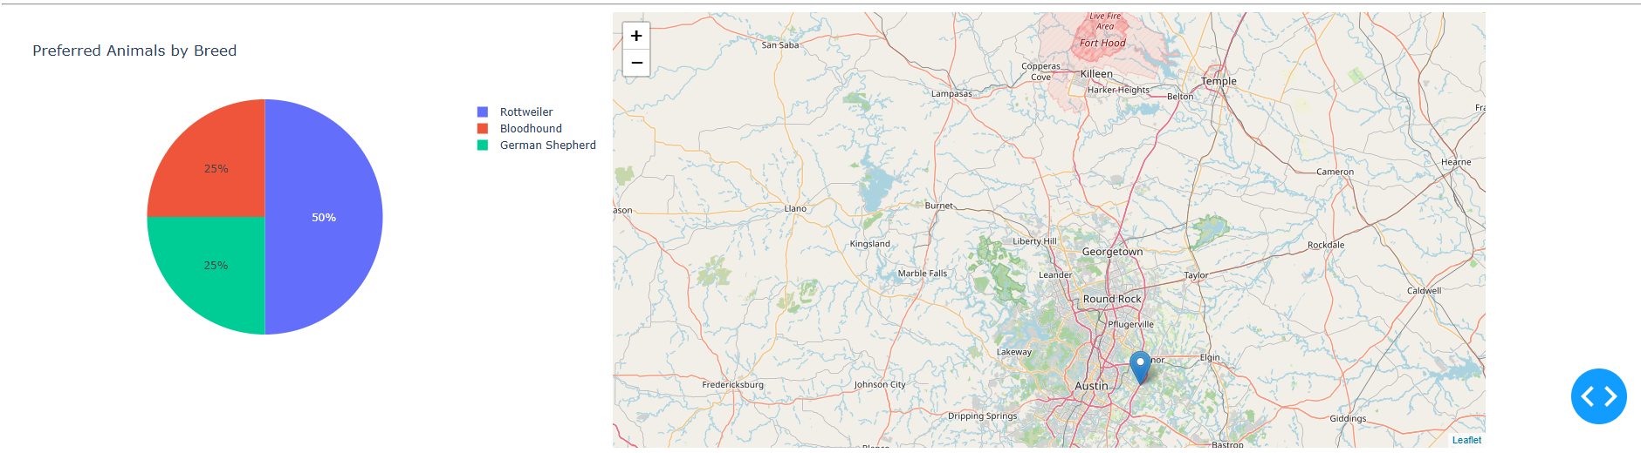Figure 4. Dashboard results after applying the Disaster or Individual Tracking filter.

Interactive Data Table and Map
The dashboard includes an interactive data table that allows the user to view animal records returned from MongoDB. The table supports features such as pagination, sorting, filtering, and row selection.
Selecting an animal from the table updates the geolocation map. The map uses the latitude and longitude values associated with the selected record to place a marker at the animal's location.
Screenshot 5 – Row Selection and Map
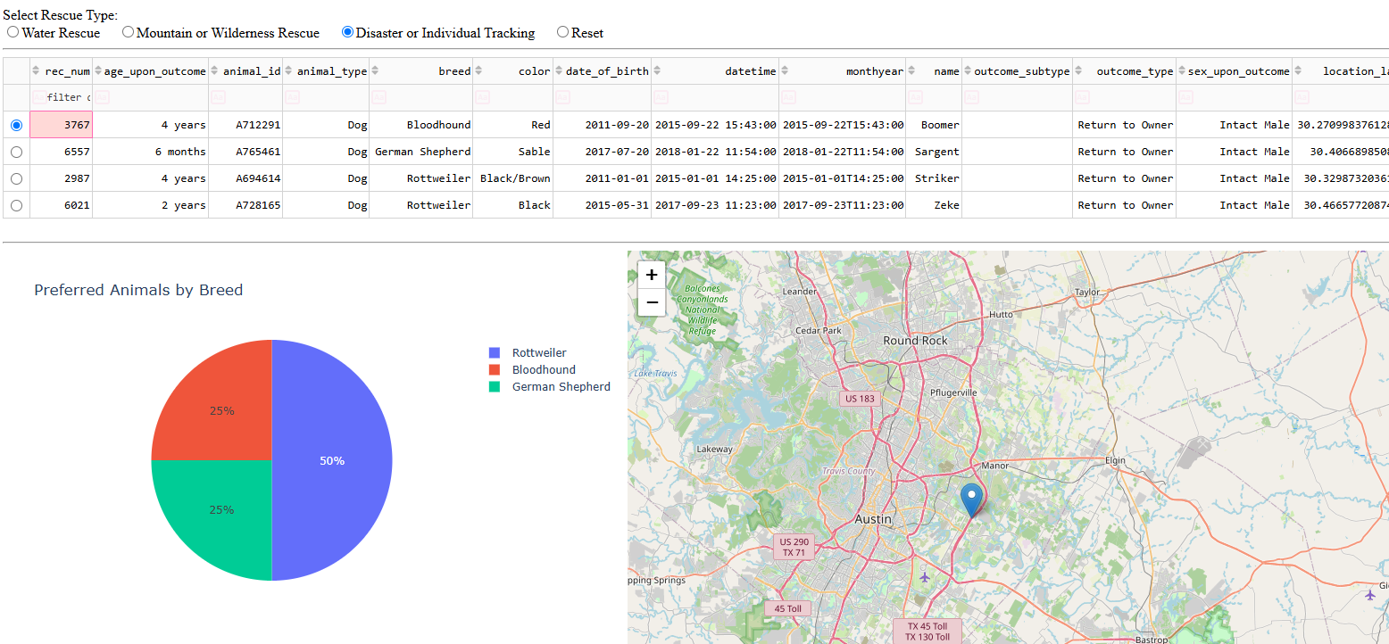Figure 5. Interactive data table and geolocation map showing the location of the selected animal.

Interactive Chart
The dashboard includes a pie chart titled Preferred Animals by Breed. The chart responds to the current rescue filter and displays the breed distribution of the resulting animals. To maintain readability when viewing the full dataset, the visualization displays the ten most frequently represented breeds.
This visualization provides users with a quick way to understand which breeds are most represented within the current results.

Reproduction Instructions
To reproduce and run the Grazioso Salvare Rescue Dashboard:
- Ensure that Python, MongoDB, and the required Python libraries are installed and available.
- Start the MongoDB service and ensure that the Austin Animal Center dataset is available in the appropriate database and collection.
- Place CRUD_Python_Module.py in the same working directory as ProjectTwoDashboard.ipynb.
- Open ProjectTwoDashboard.ipynb using Jupyter Notebook or the provided Codio environment.
- Verify that the MongoDB username, password, database, and collection information are configured correctly.
- Run the notebook cells in order.
- Run the dashboard server.
- Open the provided dashboard link in a web browser.
- Use the radio buttons to select Water Rescue, Mountain or Wilderness Rescue, Disaster or Individual Tracking, or Reset.
- Select rows in the data table to view the corresponding animal location on the map.

Challenges and Solutions
One challenge encountered during development was ensuring that each interactive dashboard component responded correctly when the underlying data changed. The callbacks needed to update the data table and chart when a rescue filter was selected while also allowing the map to respond to the selected table row.
Another challenge involved displaying breed information clearly when the complete dataset was selected. Because the dataset contains many different breeds, displaying every breed in the pie chart made the visualization difficult to read. This was addressed by displaying the ten most frequently represented breeds when generating the chart.
Testing each rescue option individually helped verify that the MongoDB queries, data table, chart, and map worked together as expected.

AI Use Acknowledgment
Generative AI (ChatGPT) was used as a support tool during this project to assist with understanding assignment requirements, troubleshooting Python and Dash errors, reviewing code structure, and debugging dashboard functionality. The resulting project was reviewed and tested in the development environment to verify that the dashboard operated as intended.

